"Endless Search" by (American Indian poet) Alonzo Lopez
Searching, forever searching.
Looking, but never finding.
Day and night, my eyes roam the world.
Searching, not knowing how to end.
This search for myself.

“SURVIVORMAN” by Sherman Alexie

While others will easily surrender
To thirst, hunger, and extremes of weather.

In Utah, one man carried another
Man on his back like a conjoined brother

And crossed twenty-five miles of desert
To safety. Can you imagine the hurt?

Do you think you could be that good and strong?
Yes, yes, you think, but you’re probably wrong.

“I Am Crying From Thirst” by Alonzo Lopez
I am crying from thirst.
I am singing for rain.
I am dancing for rain.
The sky begins to weep,
for it sees me
singing and dancing
on the dry, cracked
earth.

“I Would Steal Horses” by Sherman Alexie
For Kari
for you, if there were any left,
give a dozen of the best
to your father, the auto mechanic
in the small town where you were born
and where he will die sometime by dark.
I am afraid of his hands, which have
rebuilt more of the small parts
of this world than I ever will.
I would sign treaties for you, take
every promise as the last lie, the last
point after which we both refuse the exact.
I would wrap us both in old blankets
hold every disease tight against our skin.
Sherman Alexie
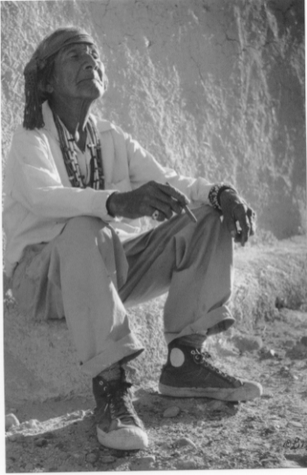
White Man’s Moccasins by Lee Marmon

